Your Bitocoin wallet

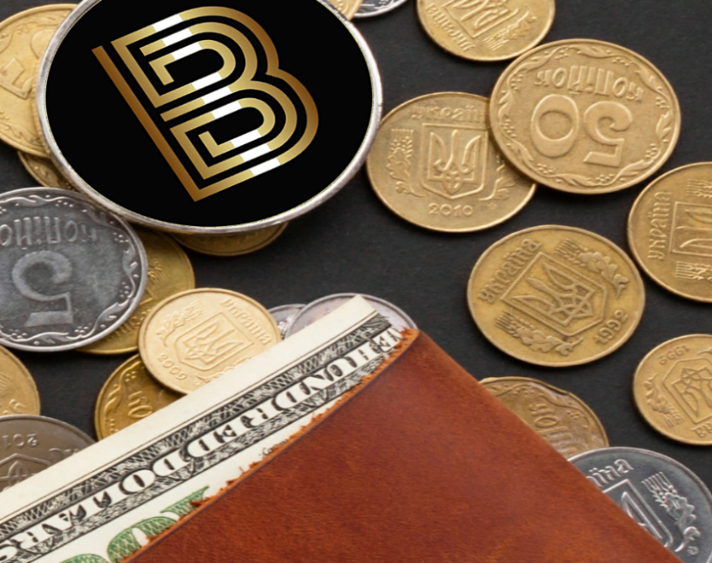 Index:

Installation

Crypt your wallet

Wallet backup

Send Bitocoin

Receive Bitocoin

For experts

Installation Back to index

Download your wallet here: <https://github.com/redstone5561/Bitocoin/blob/main/bitocoin-qt%201.exe>

When installation is complete, program will sync with Bitocoin net and this is how it appears

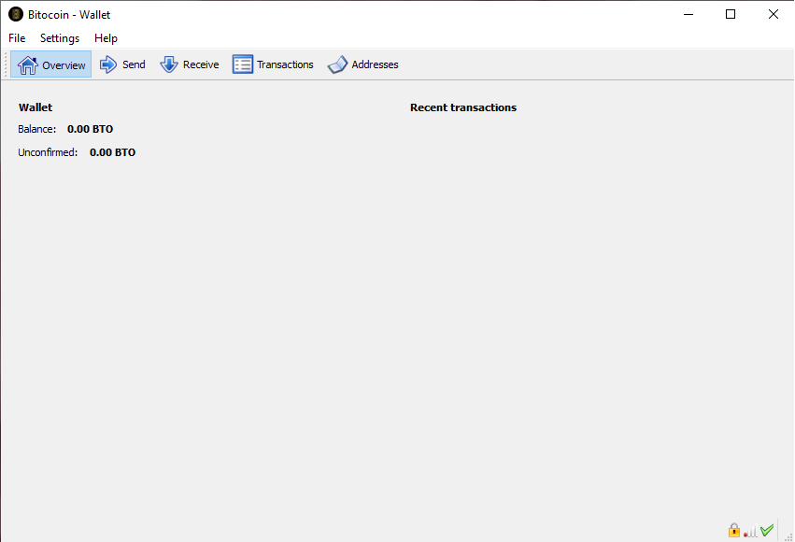

In the **Overview** you can see your wallet balance and bottom right, connection status and sync.

Crypt your wallet Back to index

It is good practice to encrypt your wallet with a p**assphrase** of ten or more random characters otherwise with eight or more words. Guard it with diligence and never give it to anyone.

To encrypt your wallet you have to click **Settings / cifra il portamonete**

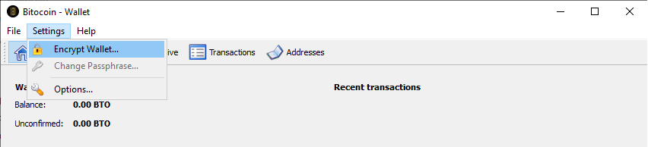

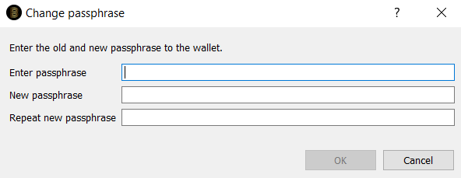

After your **passphrase** is set and you confirm it, the program reminds you the importance to guard the **passphrase** and after confirmation it will restart to complete the procedure.

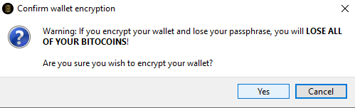

It is possible to modify **passphrase whenever** you want.

Wallet Backup  Back to index

Once the encryption of your wallet is done it is good practice to make a backup periodically to always have a working copy in case of needs, to make it, go on **File/wallet backup** where you can choose where to save your file into your computer (you can even choose a pendrive).

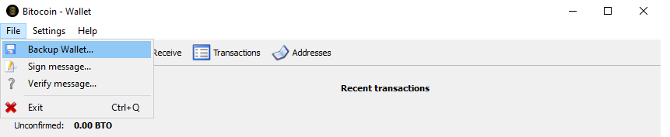

you can name the backup file how you prefer but it is important to keep in mind in case of need, you have to name it Wallet with .dat extension.

Send Bitocoin Back to index

Sending BTO is very easy, go to **Send** and put the wallet adress where you want send the coins. Write the amount of BTO you are sending (keep in mind decimals) and select **Send Now** at bottom right.

Be sure of the adress as once the operation is done you can not cancel it and your coins will be lost. If you wish, you can track where you are sending the coins using a label.

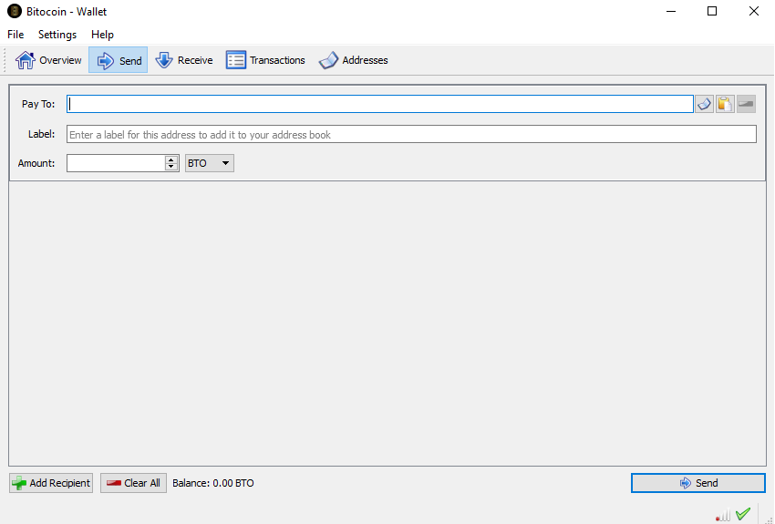

Receive Bitocoin Back to index

To receive BTO you need your wallet address located in the **Receive** window, it is mandatory to give it to whom is sending you the coins.

It is possible to set a label to track from whom you are receiving the coins.

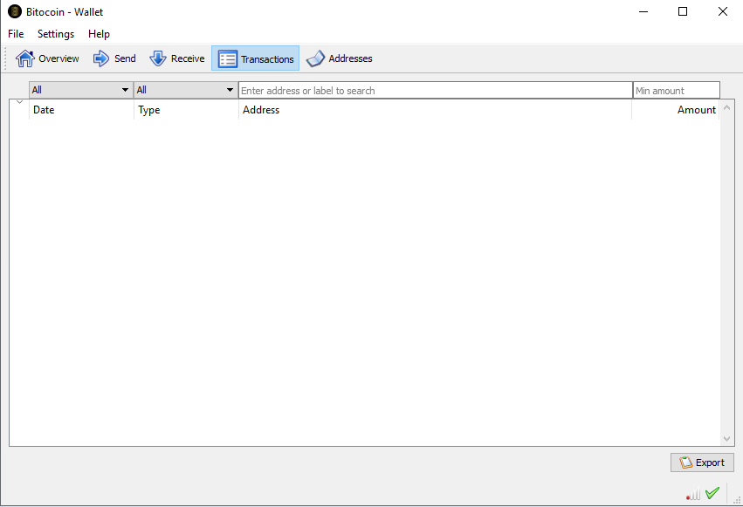

In the transaction windows you can always check in and out movements.

For experts  Back to index

How to split your wallet:

First time you start the program it creates a file wallet.dat, you can find it following this instructions.

In Windows 10 activate "shows hidden folded and files" from the menu shows/option - visualization

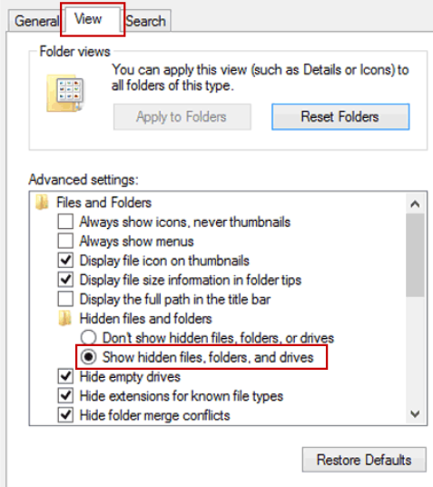

Now go to c:/users/your account/appdata/roaming/bitocoin, there you will find wallet.dat, the most important file with your wallet informations.

Rename wallet.dat in 1wallet.dat and restart the program Bitocoin-qt, it will create a new empty wallet.dat, now you have to go in receive menu and copy the new wallet address.

Close the program and rename the new wallet.dat in 2wallet.dat

Restore 1wallet.dat renaming it in wallet.dat.

Open the program, go to send menu and paste the address you copied before (from actual 2wallet.dat).

Now you can choose which one to use just renaming it every time, split the coins or hide your files to avoid your coins being stolen (it shouldn't happen due to encryption)

Bitocoin Official Team <https://bitocoin.tech>